COURSE SUBSTITIOTION

A student's program needs must be examined prior to determining whether any course should be incorporated into the program as a substitution.
Three classifications of course substitutions may be approved:
- external substitutions from outside the OSRHE transfer matrix
- external substitutions from within the OSRHE transfer matrix system, and
- internal substitutions within and between departments at SCU

Substitutions from within the OSRHE transfer matrix are approved automatically, requiring no action from the advisor. Course substitutions outside the OSRHE transfer matrix or substitutions within SCU departments are approved on an individual basis. To apply for an external substitution from outside the state transfer matrix system or an internal substitution between departments at SCU, the faculty advisor must submit a substitution request to the Office of the Registrar.
- For each course for which a substitution is being requested complete a separate course substitution/waiver form. Forms can be found on the main page of the faculty portal.
- For substitutions, the faculty advisor should acquire a course syllabus and a course description from the catalog of the institution at which the course being used for the substitution was originally taken.
- The student's faculty advisor should review the syllabus and course description to determine if the substitution is justified. Note: Similarities in course titles do not ensure similar content or necessarily mean that one course will substitute for another. To be justified as a substitution the course should have similar content and required skills throughout the entire course. The advisor should not approve courses outside of his/her teaching area unless the Chair of the appropriate Department reviews the syllabus to determine similar content.
- The substitution course is a lower-division course and the required course is upper-division, even if course titles are identical.
- The course description of the substitution course is not approximately 75% identical to the required course description.
- To obtain permission to use alternate course outside the program requirements as listed in the catalog under which the student matriculated to the program. E.g. a course listed in a program in one catalog is no longer offered as a part of a newer catalog.
- Be specific. How does the substituting meet learning objectives of the required course? Include any other important details, especially related to transfer courses.

Approval Process
1. Form is received by Registrar.
2. Form is sent for approval to the following:
a) Gen. Ed. Director if the required course is a Gen. Ed. requirement and not administered by a Department Chair.
b) Chair of Theology/Missions Dept. if the required course is a Religious Literacy requirement
c) Chair of the Department from which the course is administered if the required course is part of the student's major.
3. Form is routed back to registrar for application of equivalency to the student's degree audit. If the request is denied, the advisor will be contacted by the registrar's office.
4. The advisor should contact the student to work out other options for the requirement if the request is denied.
5. A written appeal can be made to the Dean of the student's program if the request is denied by the Department Chair.
6. A written appeal can be made to the Chief Academic Officer if the request is denied by the Dean.
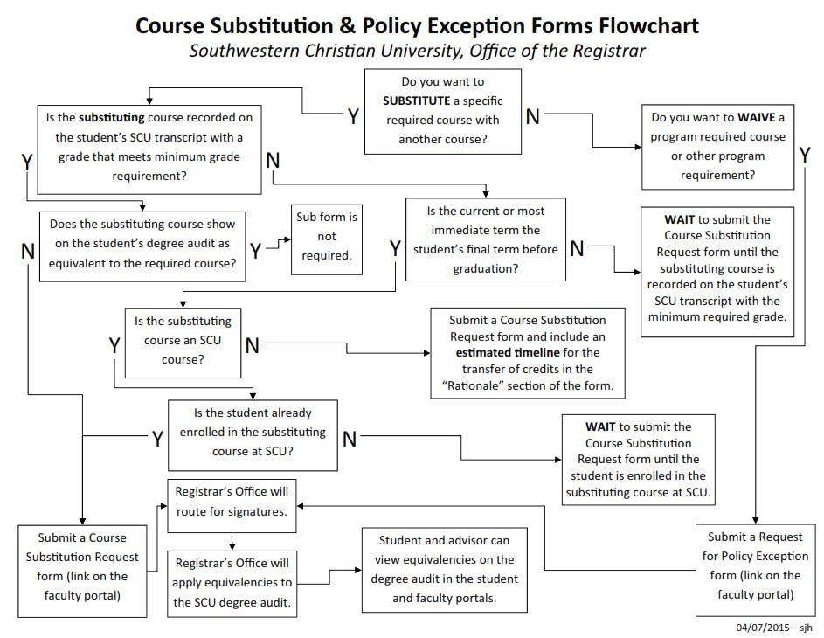

Drafted on: NA
Policy Revised: October 19, 2015, language amendments

SCU Course Substitution Request Form

This form is for advisors only (usernarne is automatically collected).
…please be sure the substitution course is on the student's SCU or transferring school transcript. …please use CORRECT course numbers and titles as reflected on the SCU transcript.
…If the substitution course is from another school, please include a course description from an official catalog or syllabus from that school for the semester in which student took the course. (Note this information in the Rationale section.)

Your username (adrian.hinkle@swcu.edu) will be recorded when you submit this form. Not adrian.hinkle? Sign out
* Required

When to Use This Form
Check the student's degree audit in the faculty portal for equivalencies already applied by the Registrar’s Office before submitting the form. If equivalencies are already applied, the Registrar's Office has already counted the course as a substitution.

- The substitution course is a lower-division course and the required course is upper-division, even if course titles are identical.

- The course description of the substitution course is not approximately 75% identical to the required course description.

- To obtain permission to use alternate course outside the program requirements as listed in the catalog under which the student matriculated to the program. E.g. a course listed in a program in one catalog is no longer offered as a part of a newer catalog.

Course Substitution & Policy Exception Forms Flowchart
Southwestern Christian University, Office of the Reg istrar
N
Y
Do you want to SUBSTITUTE a specific required course with another course?

Y
Do you want to WAIVE a program required course or other programs
Y
N
Is there substituting course recorded on the student’s SCU transcript with a grade that meets minimum grade requirement?

WAIT to submit the course substitution request form until the substituting course is recorded on the student’s SCU transcript with the minimum required grade
Y
Is the current or most immediate term the student’s final term before graduation?
N
Y
N
Sub form is not required.
Does the substituting course show on the student’s degree audit as equivalent to the required course?
Submit a Course Substitution Request form and include an estimated timeline for the transfer of credit in the “Rationale” section of the form
N
Y
Is the substituting course an SCU course?
N
WAIT to submit the Course Substitution Request form until the student is enrolled in the substituting course at SCU.
Y
Registrar’s Office will route for signatures
Submit a Request for the Policy Exception form (link on the faculty portal)
Is the student already enrolled in the substitution course at SCU?

Student and advisor can view equivalences in the degree audit in the student and faculty portal
Submit a Request for the Policy Exception form (link on the faculty portal)
Registrar’s Office will apply equivalences to the SCU degree audit

Substitution Course Description (if a transfer course)

Transfer Institution *
If the substituting course is a transfer course, name the transferring institution. (If not a transfer course, please list NA.)

Rationale for substitution. *
Be specific. How does the substituting meet learning objectives of the required course? Include any other important details, especially related to transfer courses.

Approval Process
- Form is received by Registrar.
2. Form is sent for approval to the following:
  - Gen. Ed. Director if the required course is a Gen. Ed. requirement ,
  - Head of Theology/Missions Dept. if the required course is a Religious Literacy requirement
  - Head of the Department from which the course is administered if the required course is part of the student's major.
- Form is routed back to Registrar for final approval and application of equivalency to the student's degree audit.
- If the request is denied, the advisor will be contacted.
- The advisor should contact the student to work out other options for the requirement if the request is denied.

